

**Satin Flag**

Soyang's comprehensive range: PVC-Free. Supported by full industry chain. Compatible with various printing methods.

**ST-124T/ST-124D**

**BRIEF DESCRIPTION**

- 100% polyester satin with high glossy finish

|  |  |  |  |
| --- | --- | --- | --- |
| **PROPERTIES** | **TEST METHOD** | **METRIC** | **IMPERIAL** |
| Total Weight | DIN EN ISO 2286-2, ASTM D751 | 150 g/sq.m | 4.4 oz/sq.yd |
| Base Fabric | DIN 60001, ASTM D7641 | 100%polyester | 100%polyester |
| Weave Method | N/A | Warp-knitted | |
| Shrinkage | ISO 9866-2-1991 | ≤2% | |
| Flame Resistance | DIN 4102-1-B1, NFPA 701 Test1, EN13501-1 | DIN 4102-1-B1, NFPA 701 Test1, EN13501-1 | |
| Recommend Fixation  Temperature | N/A | 190℃, 30s | |
| Width Available | DIN EN ISO 3759, ASTM D751-2006 | Max 320cm | 126" |
| Standard Length | DIN EN ISO 3759, ASTM D751-2006 | 50m | 55yds |
| NOTE: It is normal that the weight of most products will have an average fluctuation of 5%. All above information shall only used as a guide; buyers shall independently test and determine the products suitability. The mentioned data are average of test result and should not be used for the purpose of lawsuit or warranty. | | | |

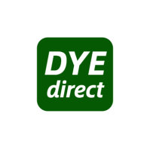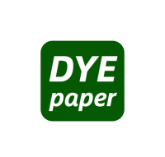

**FEATURES**

**INK PRINTABILITY**

**MATERIAL DETAILS**